**Assignment 6 MongoDB**

**Due Date:** April 17th, 2018 at 7:00 PM

**Instructions:** This assignment can either be handwritten, typed directly into the document, or take screenshots of the code in the text editor and put the images under the corresponding questions (recommended). You do not need to repeat the require, Mongo Client import, url, or MongoClient connection lines for the parts that require a code snippet. Simply provide the code snippet that is mentioned in the question, no need to provide anything else. Assume that the database will be named “db”.

This assignment is worth **5**% of your grade.

1. List two advantages of using MongoDB.

* Very lightweight database with not a lot of setup to hook into Node.js
* Incredibly easy to follow the CRUD paradigm with just a few function calls

1. 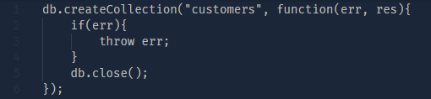Write out the code to create a collection called “customers”.
2. 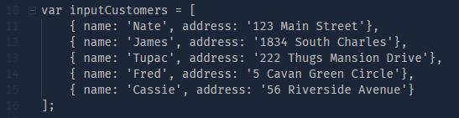Define a variable called “inputCustomers” with the following data

|  |  |
| --- | --- |
| **name** | **address** |
| Nate | 123 Main Street |
| James | 1834 South Charles |
| Tupac | 222 Thugs Mansion Drive |
| Fred | 5 Cavan Green Circle |
| Cassie | 56 Riverside Avenue |

1. 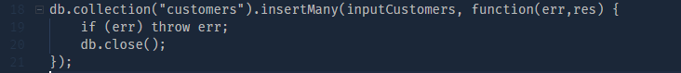 Write out the code to input “inputCustomers” into the “customer” collection
2. 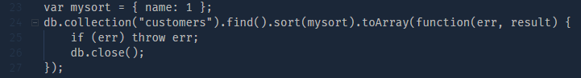Write out the code to return the customer names in ascending order from the “customer” collection
3. 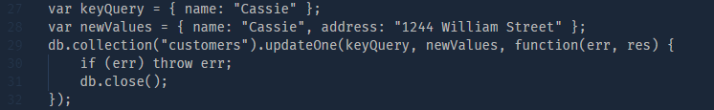Write out the code to update Cassie’s address from “56 Riverside Avenue” to “1244 William Street”
4. 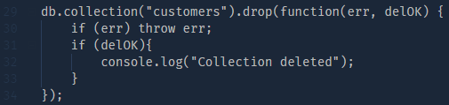Write out the code to delete the customer collection